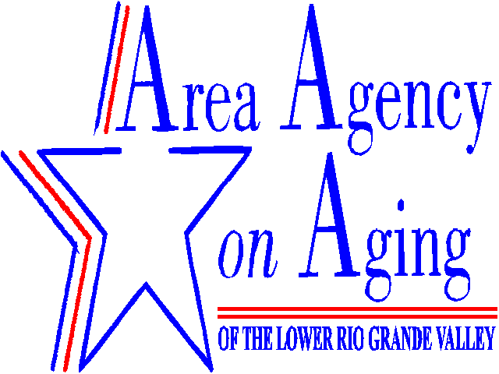 | 301 W. Railroad St.  Weslaco, Texas 78596  956-682-3481 (Tel)  956-682-8852 (Fax)  1-800-365-6131

DIRECT PURCHASE OF SERVICE APPLICATION INFORMATION
The Area Agency on Aging of the Lower Rio Grande Valley is designated by the Texas Department of Aging and Disability Services (DADS) to be the focal point for services to persons 60 or older within the AAA’s region. The AAA of the Lower Rio Grande Valley administers services funded by the Older Americans Act (OAA) with emphasis placed on frail, rural, low income, minority and limited English individuals. The AAA purchases various short-term services for eligible clients. Services are purchased from appropriate vendors that have completed a Direct Purchase of Service (DPS) Application form, and have executed a Vendor agreement with the AAA.
Eligibility to Apply: Organizations eligible to apply include private non-profit, private for-profit, and local city-county governmental entities, which have the capacity to meet the requirements of service delivery under DPS procedures.
Debarred/Suspended Parties: Debarred or suspended parties are ineligible to and are excluded from participation in this program.
Definition of Direct Purchase of Service (DPS): DPS is a contracting methodology for the purchase of services by the AAA on a client-by-client basis in lieu of annualized contracting, or a fixed sum basis. It is a procurement methodology, which provides flexibility in the purchasing of services for participants in the OAA Programs.
Application Process: Interested parties may apply for consideration for participation in the vendor pool by submitting a completed and signed direct purchase of service application, including all required attachments, and certification regarding debarment. If the application is approved by the AAA, a vendor agreement may be executed.

Area Agency on Aging of Lower Rio grande Valley
Direct Purchase of Service

Fiscal Year 2015-2016 Vendor Application/Renewal Update

Please type or clearly print application information.

APPLICATION / RENEWAL (please indicate)
Vendor Name/Legal Entity

DBA (if applicable)

Physical Address:

Mailing Address:

Tax Identification Number (SSN or Federal ID): | Fax Number (including area code):
Type of Provider:
Governmental Agency Private Non-Profit Private For Profit
City Government County Government Other:_______________
Authorizing Official: | Title:
Email Address: | Telephone:
Billing Contact Person and billing address: | Title:
Email Address: | Telephone:
Number of Years Organization has been in business:  ______ Years | Is Organization Bonded (Attach certificate of bonding ins.)  Yes No
Has anyone involved in the direct provision of client services been convicted of a felony (In-home Services only)?  Yes No | If yes, provide details:
Does Organization have liability insurance?  (Attach certificate of all insurances)  Yes No | Attach a copy of all applicable State and Federal licenses and /or certifications for your business.
Conflicts of Interest: Attach information of applicable names and relationship of any employee(s) or officers of your organization that may have a conflict of interest with the LRGVDC-Area Agency on Aging staff person or Advisory Council member.

Page 1
Service and Bidding Information:

- Proposed Service:
A. Service Area:

B. Proposed AAA cost per Unit $ Standard cost per Unit: $
NOTE: For Home Repair/Modification: Work Performed “As Bid” or under the $250 rule.

- Proposed Service:
A. Service Area:

B. Proposed AAA cost per Unit $ Standard cost per Unit: $
NOTE: For Home Repair/Modification: Work Performed “As Bid” or under the $250 rule.

- Proposed Service:
A. Service Area:

B. Proposed AAA cost per Unit $ Standard cost per Unit: $
NOTE: For Home Repair/Modification: Work Performed “As Bid” or under the $250 rule.

- Proposed Service:
A. Service Area:
B. Proposed AAA cost per Unit $ Standard cost per Unit: $
NOTE: For Home Repair/Modification: Work Performed “As Bid” or under the $250 rule.

NOTE: See attached service and unit definition(s) for specific service and unit information. If any rate listed above is higher than those normally charged to DADS-RLS eligible seniors or to other agencies, please attach a thorough explanation for the rate difference. If your agency contracts with another Area Agency on Aging and the above proposed rate is higher than the current rate given to the Lower Rio Grande Valley Area Agency on Aging, attach a thorough explanation for the rate difference.

Documentation of Standard Fees such as a fee schedule or certification of cost is required for organizations proposing to provide services at reduced rates. The Lower Rio Grande Valley Area Agency is required to provide a non-federal match for all Older Americans Act funds. The Area Agency on Aging reports the difference in rates as program match.

Page 2
Additional Attachments:

- Certification of Signatory Authority
- Signed Statement indicating compliance with the Civil Rights Act of 1964
- Signed Assurance of Compliance with Section 504 of the Rehabilitation Act of 1973
- Signed Non-Conflict of Interest Certification
- Signed Certification Regarding Debarment

Signature:

I certify that the information provided in this application is true and correct to the best of my knowledge.

Printed Name/Title Date

Authorized Signature

Page 3

